### Semester One Examination, 2016

### Question/Answer Booklet

# MATHEMATICS

**SOLUTIONS**

**METHODS**

**UNIT 1**

## Section One:

## Calculator-free

|  |  |  |  |  |  |  |  |  |
| --- | --- | --- | --- | --- | --- | --- | --- | --- |
| Student Number: In figures |  |  |  |  |  |  |  |  |

In words

Your name

## Time allowed for this section

Reading time before commencing work: five minutes

Working time for section: fifty minutes

## Materials required/recommended for this section

***To be provided by the supervisor***

This Question/Answer Booklet

Formula Sheet

***To be provided by the candidate***

Standard items: pens (blue/black preferred), pencils (including coloured), sharpener, correction fluid/tape, eraser, ruler, highlighters

Special items: nil

## Important note to candidates

No other items may be taken into the examination room. It is **your** responsibility to ensure that you do not have any unauthorised notes or other items of a non-personal nature in the examination room. If you have any unauthorised material with you, hand it to the supervisor **before** reading any further.

## Structure of this paper

|  |  |  |  |  |  |
| --- | --- | --- | --- | --- | --- |
| Section | Number of questions available | Number of questions to be answered | Working  time (minutes) | Marks available | Percentage of exam |
| Section One:  Calculator-free | 7 | 7 | 50 | 51 | 35 |
| Section Two:  Calculator-assumed | 13 | 13 | 100 | 98 | 65 |
|  | | | **Total** | 149 | 100 |

## Instructions to candidates

1. The rules for the conduct of examinations are detailed in the school handbook. Sitting this examination implies that you agree to abide by these rules.
2. Write your answers in this Question/Answer Booklet.
3. You must be careful to confine your response to the specific question asked and to follow any instructions that are specified to a particular question.
4. Spare pages are included at the end of this booklet. They can be used for planning your responses and/or as additional space if required to continue an answer.

* Planning: If you use the spare pages for planning, indicate this clearly at the top of the page.
* Continuing an answer: If you need to use the space to continue an answer, indicate in the original answer space where the answer is continued, i.e. give the page number. Fill in the number of the question that you are continuing to answer at the top of the page.

1. **Show all your working clearly**. Your working should be in sufficient detail to allow your answers to be checked readily and for marks to be awarded for reasoning. Incorrect answers given without supporting reasoning cannot be allocated any marks. For any question or part question worth more than two marks, valid working or justification is required to receive full marks. If you repeat any question, ensure that you cancel the answer you do not wish to have marked.
2. It is recommended that you **do not use pencil**, except in diagrams.
3. The Formula Sheet is **not** to be handed in with your Question/Answer Booklet.

Section One: Calculator-free 35% (50 Marks)

This section has**seven (****7)** questions. Answer **all** questions. Write your answers in the spaces provided.

Working time for this section is 50 minutes.

Question 1 (8 marks)

Solve the following equations for x.

(a) . (2 marks)

|  |
| --- |
| **Solution** |
|  |
| **Specific behaviours** |
| ✓ re-writes equal to zero and factorises  ✓ determines values of x |

(b) . (3 marks)

|  |
| --- |
| **Solution** |
|  |
| **Specific behaviours** |
| ✓ factors out x  ✓ factorises quadratic  ✓ states solutions |

(c) . (3 marks)

|  |
| --- |
| **Solution** |
|  |
| **Specific behaviours** |
| ✓ multiplies through by common denominator  ✓ expands and simplifies  ✓ states solution |

Question 2 (8 marks)

(a) A function is defined by .

(i) Determine the coordinates of the y-intercept of the graph of . (1 mark)

|  |
| --- |
| **Solution** |
|  |
| **Specific behaviours** |
| ✓ substitutes x=0 and writes as coordinate |

(ii) Expand and simplify . (2 marks)

|  |
| --- |
| **Solution** |
|  |
| **Specific behaviours** |
| ✓ expands quadratic factor correctly  ✓ expands and simplifies rest of function |

(iii) The coordinates of one of the turning points of the graph of  can be read from the function definition. State the coordinates of this turning point. (1 mark)

|  |
| --- |
| **Solution** |
| (2, 0) |
| **Specific behaviours** |
| ✓ states coordinates |

(b) Consider the function .

(i) Determine . (1 mark)

|  |
| --- |
| **Solution** |
|  |
| **Specific behaviours** |
| ✓ substitutes correctly |

(ii) Factorise . (3 marks)

|  |
| --- |
| **Solution** |
|  |
| **Specific behaviours** |
| ✓ uses root from (i) to determine one factor  ✓ determines remaining quadratic  ✓ factorises fully |

Question 3 (7 marks)

Consider the points A(6, -10) and B(-2, -4).

(a) If B is the midpoint of A and C, determine the coordinates of C. (2 marks)

|  |
| --- |
| **Solution** |
|  |
| **Specific behaviours** |
| ✓ determines x-coordinate  ✓ determines y-coordinate |

(b) Determine the equation of the line through A that is perpendicular to AB. (3 marks)

|  |
| --- |
| **Solution** |
|  |
| **Specific behaviours** |
| ✓ calculates gradient of AB  ✓ states perpendicular gradient  ✓ calculates y-intercept and writes equation |

(c) Explain whether the line through A and B will intersect the line with equation . (2 marks)

|  |
| --- |
| **Solution** |
| No, as the lines are parallel and A does not lie on the given line. |
| **Specific behaviours** |
| ✓ states no with reason  ✓ states parallel but not coincident |

Question 4 (7 marks)

(a) Part of the graph of  is shown below.

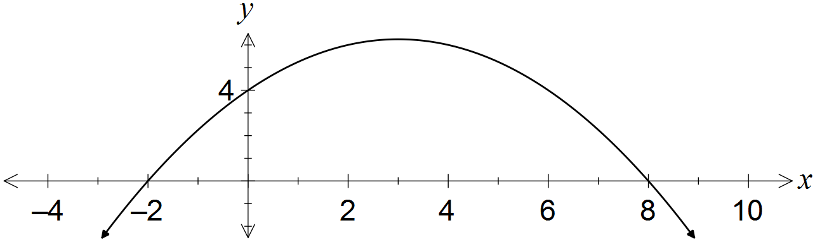

Determine the values of the coefficients a and b. (3 marks)

|  |
| --- |
| **Solution** |
|  |
| **Specific behaviours** |
| ✓ uses roots to express in factored form  ✓ uses y-intercept to find a  ✓ expands and states b |

(b) A quadratic has equation . Determine

(i) the coordinates of its turning point. (2 marks)

|  |
| --- |
| **Solution** |
|  |
| **Specific behaviours** |
| ✓ completes square, or uses x=-b/2a  ✓ states coordinates |

(ii) the exact values of the zeros of the quadratic. (2 marks)

|  |
| --- |
| **Solution** |
|  |
| **Specific behaviours** |
| ✓ uses quadratic formula or completes square  ✓ states both roots in exact form |

Question 5 (8 marks)

(a) A circle of radius 5 has its centre at (6, -4).

(i) Determine the equation of this circle. (2 marks)

|  |
| --- |
| **Solution** |
|  |
| **Specific behaviours** |
| ✓ uses standard circle form with correct radius  ✓ correct equation |

(ii) State, with justification, whether the point (9, -8) lies on the circle. (1 mark)

|  |
| --- |
| **Solution** |
|  |
| **Specific behaviours** |
| ✓ substitutes point into equation from (a) and interprets |

(b) Determine the centre and radius of the circle with equation  .

(3 marks)

|  |
| --- |
| **Solution** |
| Hence centre at (2, -3) and radius 2 |
| **Specific behaviours** |
| ✓ factors x terms  ✓ factors y terms  ✓ states centre and radius |

(c) Determine the coordinates of the vertex and the equation of the axes of symmetry of the curve with equation . (2 marks)

|  |
| --- |
| **Solution** |
| Vertex at (-3, 0) and symmetrical about . |
| **Specific behaviours** |
| ✓ states vertex  ✓ states equation of line of symmetry |

Question 6 (8 marks)

The graph of  is shown below, where a, b, c and k are constants and.

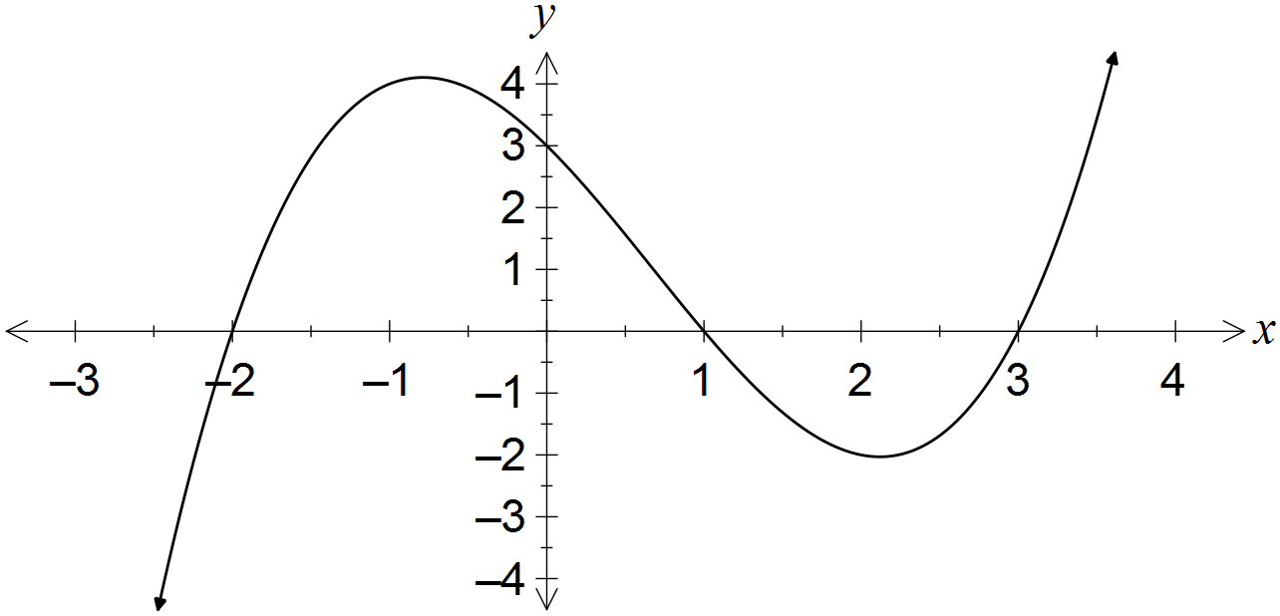

(a) Determine the values of the constants a, b, c and k. (4 marks)

|  |
| --- |
| **Solution** |
|  |
| **Specific behaviours** |
| ✓ identifies that coefficients are roots  ✓ identifies values of coefficients correctly  ✓ use y-intercept to find k  ✓ determines value of k |

(b) On the axes below, sketch the graph of . (4 marks)

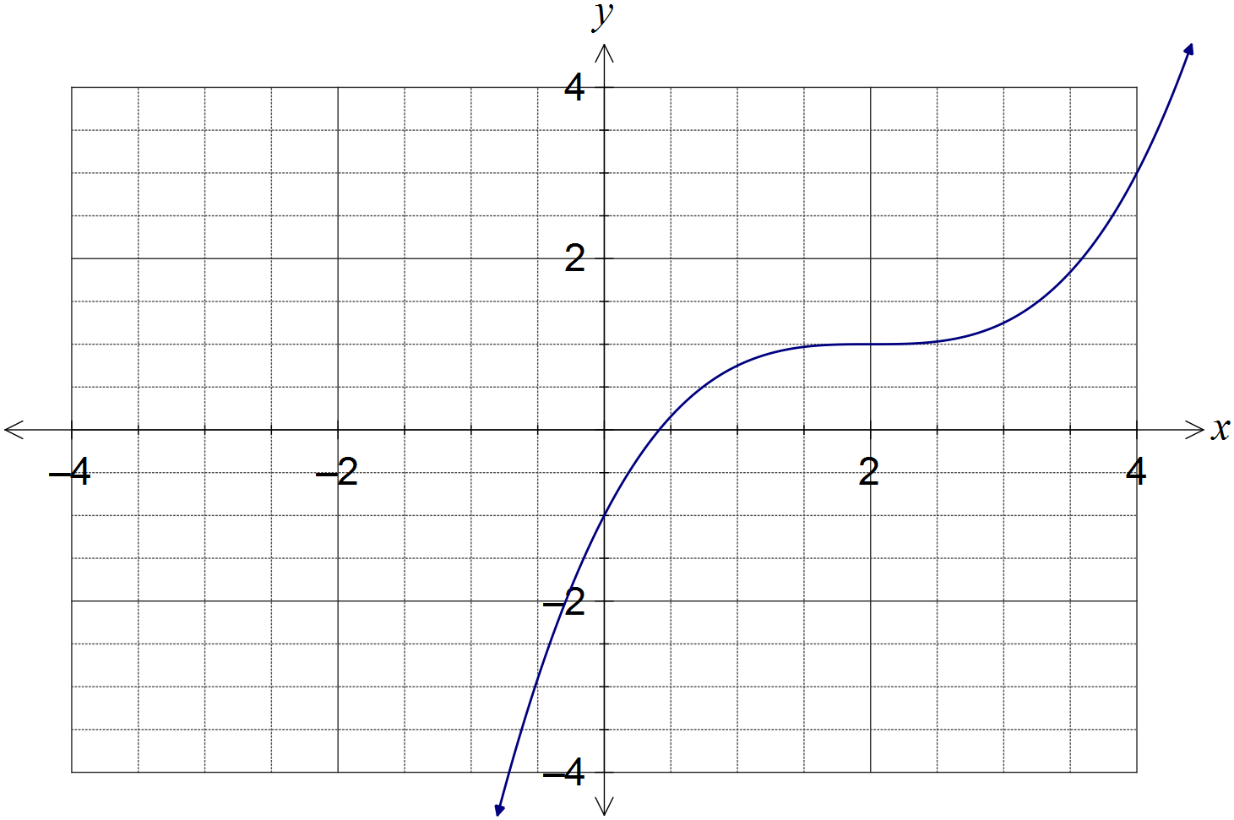

|  |
| --- |
| **Solution** |
| See graph |
| **Specific behaviours** |
| ✓ y-intercept  ✓ horizontal point of inflection at (2, 1)  ✓ passes close to (4,3)  ✓ general shape |

Question 7 (5 marks)

(a) Simplify . (2 marks)

|  |
| --- |
| **Solution** |
|  |
| **Specific behaviours** |
| ✓ uses difference formula  ✓ simplifies |

(b) Show that the exact value of  is . (3 marks)

|  |
| --- |
| **Solution** |
|  |
| **Specific behaviours** |
| ✓ splits angle  ✓ uses difference formula  ✓ substitutes exact values and simplifies |

Additional working space

Question number: _________

Additional working space

Question number: _________

© 2016 WA Exam Papers. Rossmoyne Senior High School has a non-exclusive licence to copy and communicate this paper for non-commercial, educational use within the school. No other copying, communication or use is permitted without the express written permission of WA Exam Papers.